|  |  |  |
| --- | --- | --- |
| **Module Code** | **:** | EE042-4-2-IES |
| **Intake Code** | **:** | APU2F2209CE |
| **Lecturer Name** | **:** | Hazwani Binti Mohd Rosli |
| **Hand in Date** | **:** | 14/12/2022 |
| **Student TPnumber** | **:** | 063251 |
| **Student name** | **:** | PEDRO FABIAN OWONO ONDO MANGUE |

Contents

INTRODUCTION 3

TABLE OF INPUTS VALUES 4

GRAPHS FOR THE INPUTS 5

ANALYSIS FOR OPEN CIRCUIT 6

TABLE OF RESULTS FOR THE READINGS AND THE CALCULATIONS 6

ANALYSIS FOR SHORT CIRCUIT 7

TABLE OF THE RESULTS, READING, AND CALCULATIONS (Short Circuit) 7

# INTRODUCTION

A transformer is a static electrical machine which transforms alternating electrical power from one voltage and current level to another voltage and current level by means of an intermediate conversion to a magnetic field. It consists of two or more isolated windings, of a certain resistance and self-inductance, which are coupled by mutual induction (M), i.e., by mutual magnetic fluxes which must be time-varying for transformer action (e.m.f.) to exist.

This magnetic link defines the values of the inductances (L) and will depend on the nature of the magnetic circuit, i.e., its magnetic reluctance, which is a function of the material used, and of the existing dispersed flux (ϕl), which generally has a different reluctance to that of the mutual flux. On the other hand, the stray and magnetizing inductance is a function of the square of the number of turns, but the mutual inductance depends on the product of the number of turns.

An electric motor is a machine that converts electrical energy into mechanical energy. Its principle supports the following statement: When a current conductor is placed in a magnetic field, it experiences a mechanical force.

**Figure 1: Simplified Transformer Schematic. Figure 2: DC Motor schematic**

Note:

MATLAB R2022a is being implemented to obtain the electrical components, as well as the Simulink and Simscape libraries.

# 

# TABLE OF INPUTS VALUES

* **Resistance, armature current and speed**

Voltage is set as 220V

|  |  |  |  |
| --- | --- | --- | --- |
| Resistance | Armature current | Speed rad/s | Speed rpm |
| 30.5 | 3.279 | 71.53 | 683 |
| 40.5 | 3.033 | 57.79 | 551.8 |
| 50.5 | 2.758 | 47.91 | 457.5 |
| 60.5 | 2.507 | 40.51 | 386.9 |
| 70.5 | 2.287 | 34.79 | 332.2 |

**Table 1**

* **Resistance, field current and speed**

Voltage is set as 250V

|  |  |  |  |
| --- | --- | --- | --- |
| Resistance | Field Current | Speed rad/s | Speed rpm |
| 25 | 0.7547 | 146.9 | 1403 |
| 30 | 0.7407 | 149.7 | 1429 |
| 35 | 0.7273 | 152.4 | 1456 |
| 40 | 0.7143 | 155.2 | 1482 |
| 45 | 0.7018 | 158 | 1508 |

**Table 2**

* **Resistance, voltage, and speed**

Field initial current value is set as 2.308 with V=600, Resistance=20

|  |  |  |  |  |
| --- | --- | --- | --- | --- |
| Resistance | Voltage | Speed rad/s | Speed rpm | Field Current |
| 20 | 600 | 144.4 | 1379 | 2.308 |
| 30 | 623.2 | 150 | 1432 | 2.308 |
| 40 | 646.24 | 155.5 | 1485 | 2.308 |
| 50 | 669.32 | 161.1 | 1538 | 2.308 |
| 60 | 692.4 | 166.6 | 1591 | 2.308 |

**Table 3**

# GRAPHS FOR THE INPUTS

# ANALYSIS FOR OPEN CIRCUIT

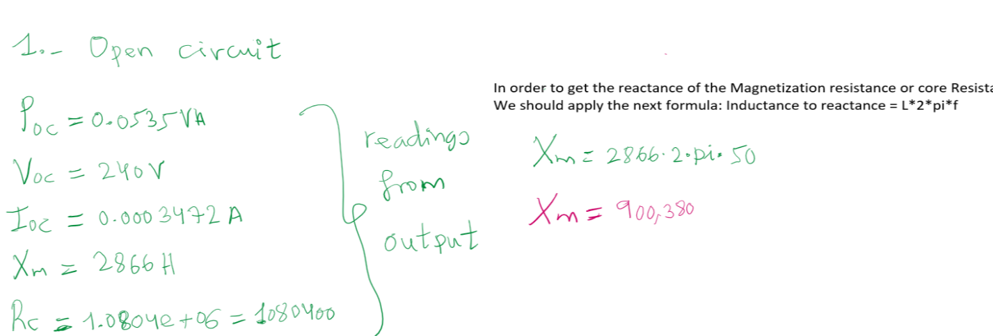**OPEN CIRCUIT**

Illustration 1: calculations

# TABLE OF RESULTS FOR THE READINGS AND THE CALCULATIONS

|  |  |  |
| --- | --- | --- |
|  | Values obtained from output(simulation) | Values obtained from calculations(formulas) |
| Xm | 900380 | 856190 |
| Rc | 1080400 | 1171400 |

# ANALYSIS FOR SHORT CIRCUIT

**

Illustration 2: calculations

# TABLE OF THE RESULTS, READING, AND CALCULATIONS (Short Circuit)

|  |  |  |
| --- | --- | --- |
|  | Values obtained from output(simulation) | Values obtained from calculations(formulas) |
| R01/R1 | 4.3218 | 4.2763 |
| X01 | 144.0609 | 144.1456 |

**ANALYSIS OF OPEN AND SHORT CIRCUITS**

* Properties setting of the voltage output

The property setting has been set by default, i.e., no parameter values have been manipulated or changed in the property setting apart from the frequency which has been set to a value of 50Hz.

* Power, current, and voltage output
* Iron and copper losses of the transformer

In open circuit iron loss is equal to the power input which is 0.0535 while the cupper loss is equal to 5.9260. You may refer to both illustration 1 and 2 above.

* Total
* equivalent resistance, reactance and impedance of both core and winding of the transformer